Chapter 1.
1. Laravel currently supports databases, including
a. MySQL, PostgreSQL, SQLite, Microsoft SQL Server
b. MySQL, Oracle , SQLite, Microsoft SQL Server
c. MySQL, PostgreSQL, SQLite, Microsoft Access
d. MySQL, SQLite

2. App directory contains
a. Controller, Middleware
b. Model , View, Controller
c. Model, Controller, Middleware
D. view, controller

3. Artisan is a
a. Plugins
b. Api
c. Command line interface
d. Cmd

4. Bootstrap directory used to
a. Initialize a laraval application
b. Call laravel library functions
c. Load the configuration files
d. Load laravel classes and models
e. Define the key directory of app and public

5. The primary function of composer is
a. Installing and updating required application package [pg-14]
b. Configuring laravel application
c. Creating database in the Laravel

6. What is composer.json?
a. This file identifies the packages you like to integrate into your application.
b. This file is used to configure the composer package manager.
c. This is used to regularly maintain your application package.

7. What is the composer.lock file used for?
a. It is used to contain information about the state of the installed composer package at the time when packages were first installed and/or updated.
b. It is used to contain information about the state of the installed composer package at the time these packages were last installed and/or updated.
c. It is used to lock all the packages so that it would never be change later.
D. none

8. Which directory is used to store database credentials, the cache, e-mail delivery and session settings?
a. Database
b. Session
c. Config
d. Public

9. Public directory serves as your application’s root directory.
a. True
b. False

10. Which directory houses .htaccess , robots.txt and favicon files?
a. Config
b. Public
c. Model
d. Resources

11. The resources directory contains
a. Raw assets (CoffeeScript,SCSS,etc.)
b. Views
c. Models
d. Both a and b

12. The vendor directory contains [pg-17]
a. Third-party code
b. Controllers
c. Laravel Framework code
d. Assets
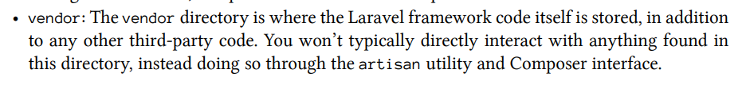

13. Which command is used to start PHP’s built-in development server?
a. %>php start server
b. %>php start dev server
c. %>php artisan serve
d. %>phparisan server

14. Which is the correct URL for PHP built-in development server?
a. http://localhost:8080
b.http://localhost:8000
c. http://localhost:80
d. http://localhost/laravel/

15. Which artisan CLI command is used to update your project’s namespace?
a. %>php artisan update app
b. %>php artisan app:name my_project [pg-19]
c. %>php artisan update:my_app
d. %>php artisan namespace:my_app

16. cache.php supports caching drivers including [pg-19]
a. filesystem, database
b. filesystem, database, mem-cached, redis
c. filesystem, mem-cached, redis
D. none

17. Which of the following is not Laravel configuration files?
a. Mail.php
b. Queue.php
c. Config.php
d. App.php

18. Which configuration file defines any third-party service-specific settings?
a. Filesystems.php
b. Session.php
c. Services.php [pg-20]
d. Third-party.php
19. Which is not laraval logging function?
a. \Log::debug()
b. \Log::info()
c. \Log::critical()
d. \Log::print_errors()

20. Where to find log files in laravel?
a. Storage\logs
b. App\logs
c. Resources\Logs
d. Public\Logs

- Does Laravel currently support several databases?
a. True
b. False

- The _______ directory contains your project’s cache, session and log data. [pg-17]

a. Database
b. Resources
c. Storage
d. Public

- Which file is responsible for the application URL, timezone, locale autoload service provider? [pg-19]

a. auth.php
b. app.php
c. cache.php
d. Compile.php

- Which file is responsible for user authentication? [pg-19]
a. auth.php
b. app.php
c. cache.php
d. Compile.php

- Which file allows you to define additional class files?[pg-19]
a. auth.php
b. app.php
c. cache.php
d. Compile.php

- Which file is need to configure to use third-party service such as Mandrill for e-mail delivery? [pg-20]
a. filesystems.php
b. mail.php
c. services.php
d. Session.php

- Which file defines the default location of your project’s view?
a. filesystems.php
b. mail.php
c. config.php
d. View.php [pg-20]

- Which directory contains the “robots.txt” file? [pg-16]
a. app
b. public
c. config
d. Storage

- The dd() is a ---------
a. helper function [pg-22]
b. controller function
c. session function
d. None

Chapter 2
1. Which is the correct syntax to making GET request in laravel?
a. Route::get(‘/’,function(){ … }); [pg-35]
b. Route::post(‘/’,function(){ … });
c. Route::request(‘/’,function(){ … });
d. Get::route(‘/’,function(){ … });

2. Which is the correct syntax to call a view from a router in laravel which is located at resources/views/product/items.blade.php directory?
a. Return view(“items”)
b. Return view(“items.blade.php”)
c. Return view(“view/product/items”)
d. Return view(“product.items”)

3. Which is the correct path to saving controller files in laravel?
a. Resources/controllers
b. App/controllers
c. App/Http/controllers
d. Controllers

4. Which is the correct path to save models in the thelaraval?
a. Resources/Models
b. App/Models (in laravel 9)
c. App/Http/Providers
d. App/ (in laravel 5) [pg-69]

5. How to create controller using artisan?
a. $ php artisan make:controller [ControllerName]
b. $ php artisan make:Controller [ControllerName]
c. $ php artisan make:[ControllerName] controller
d. $ artisan make:[ControllerName] controller

6. Which is the parent class to make a new controller?
a. AppController
b. Controller
c. LController
d. MyController

7. Which namespace is used to handle the entire form request in laraval?
a. Use Illuminate\Http\Requests
b. Use Illuminate\Http\Request
c. Use App\Requests
d. Use App\Http\Request

8. Which router indicates the view is loaded via the controller class? [pg-37]
a. Rout::get(‘/’,’MyController@index’);
b. Rout::get(‘/’,function(){ … });
c. Route::get(‘/’,function(){ return view(‘index’) });
d. None

9. What is blade in Laraval?
a. A plugin
b. A template Engine
c. An API
d. A Helper

10.Which is the correct syntax to pass multiple variables to the view?
a. return view(‘home’)->with(‘projects’,$projects)->with(‘modules’,$modules)
b. return views(‘home’)->with(array(‘projects’=>$projects, ‘modules’=>$modules))
c. return views(‘home’, array(‘projects’=>$projects, ‘modules’=>$modules)))
[according to vcampusbd]

11. Which is the correct way to configure a local database to the laravel?
a. Configure app/config/database.php file
b. Configure config/databases.php file
c. Configure .env file
D. none

12. Which namespace is used to make available DB object?
a. Use Database
b. Use DB
c. Use MySql
d. Use DB_ALL

13. Which function is used to get all records from product table? [pg-98]
a. $result=DB::table(‘product’)->getAll();
b. $result=DB::table(‘product’)->get();
c. $result=DB::get(‘product’)->table();
d. $result=DB->table(‘product’)->get();

14. Which function is used to redirect requests to project root?
a. return header(‘/’);
b. return head(‘/’);
c. return redirect(/’);
d. return redirect(‘/home’);

15. Which convention is used to make a view for a blade engine? [* indicate any file name]
a. *.b.php
b. *.be.php
c. *.blade.php
d. *.php
16.View variables can be printed as
a. {}
b. { $variable }
c. {{ $variable }}
d.{

17. How can you determine variable existence in blade expression?
a. {{ if($name)?$name: ’Default Value’ }}
b. {{ $name or ‘Default Value’ }}
c. {{ isset($name)?$name:’Default Value’}}
D. none

18.Which blade engine expression is used to escape dangerous input?
a. {{ … }} (in laravel earlier versions)[pg-46]
b. {{{ … }}} (in laravel4)[pg-46]
c. {!! … !!} (in laravel5)[pg-46]
d. {! … !}

19. Which is the correct looping syntax in term of blade engine? [pg-47]
a. @foreach($lists as $list) … @endforeach
b. @for($i=0;$i<len($list);$i++) … @endforeach
c. @while … @endwhil
d. None

20. Which is the correct forelse syntax in blade engine? [pg-47]
a. @for … @else … @endfor
b. @forelse … @empty … @endforelse
c. @forelse … @else … @endforelse
d. None

21. Which of the following is not the correct selection syntax for blade engine? [pg-48]
a. @if … endif
b. @if … @else … @endif
c. @if … @elseif … @endif
d. @if … @if .. @end @end

22. Which is not correct directive for blade engine?
a. @yield
b. @section
c. @show
d. @content

23.Which function is used to link external CSS file in blade engine?
a. {! HTML::css(‘path’) !}
b. {!! HTML::style(‘path’) !!} [pg-52]
c. {{ HTML::css(‘path’) }}
d. {{ HTML::style(‘path’) }}

24.Which function is used to link external JS files in the blade engine?
a. {! HTML::js(‘path’) !}
b. {!! HTML::javascript(‘path’) !!}
c. {{ HTML::script(‘path’) }}
d. {!! HTML::script(‘path’) !!} [pg-52]

25. Which of the following commands is used to create a controller?
a. php artisan makes: controller WelcomeController
b. php artisans make: controller WelcomeController
c. php artisan make: controllers WelcomeController
d. php artisan make: controller WelcomeController

26. Static content view, you don’t need to create a controller? [pg-3
5]
a. True
b. False

27. Which file defines your application URL?
a. Controller
b. Route
c. model
d. Helper

28. Which of the following is not correct?
a. return view(“home”)->with(‘city’, $city);
b. return view(“home”)->with($city , ‘city’);
c. return view(“home”)->with(‘city’, ‘city’);
d. None of above

29. It is possible to create a controller alias?
a. True
b. False

30. Is it possible to use multiple “with” methods in view files?
a. True
b. False

31. How to determine variable existence?
a. Welcome, {{$name or ‘Guest’}}
b. Welcome, {{‘Guest’ or $name}}
c. Welcome, {{$name}}
d. Welcome, {{‘Guest’}}

32. Which of the following loops is correct?
a. @foreach($data as $value){{$value}}@foreach
b. @foreach($data as $value){{$value}}@endforeach
c. @foreach($data $value){{$value}}@foreach
d. @foreach($data $value){{$value}}@foreach

33. Which of the following is false?
a. @extends directive tells which layout should be use
b. File extension of view should be like “example.blade.php”
c. @yield directive identifies the id of the section [pg-49]
d. None of above
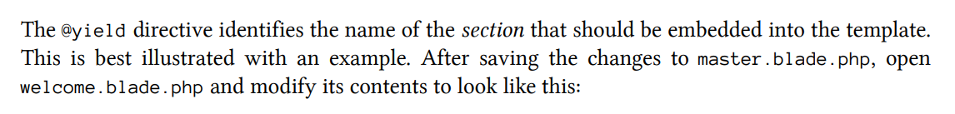

34. Which of the following is correct?
a. Route::get(‘/’, function(){ return view(‘welcome’); });
b. Route::get(‘/’, function(){ return view(‘welcome.blade’); });
c. Route::get(‘/’, function(){ return view(‘welcome.blade.php’); });
d. Route:get(‘/’, function(){ return view(‘welcome’); });

35. Which of the following commands is used to create a model?
a. php artisan makes: modelWelcomeModel
b. php artisans make: model WelcomeModel
c. php artisan make: modelsWelcomeModel
d. php artisan make: model WelcomeModel

36. Migration offers file-based approach to changing the structure of your models
a. True
b. False [pg-69]

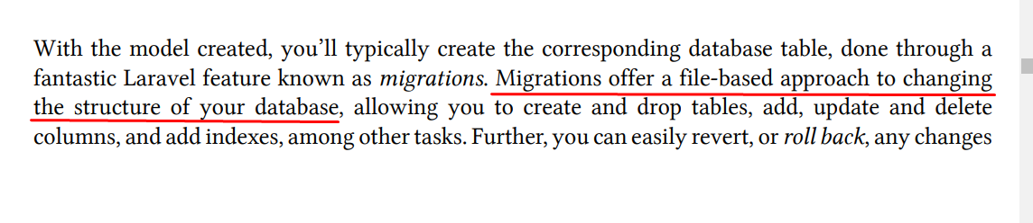

37. The $table->timestamps() function include
a. created_at timestamp column
b. updated_at timestamp column
c. created_at and updated_at timestamp columns[PG-71]
d. create_at and update_at timestamp columns

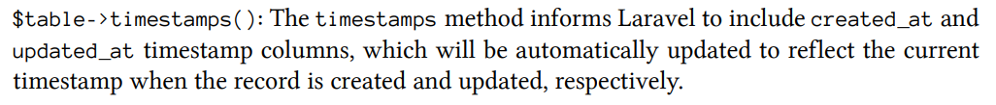

38. Which of the following is not a RESTful method? [pg-83]
a. create()
b. show()
c. edit()
d. delete()

39. By default, a RESTful controller has ____ methods?
a. 5
b. 6
c. 7 [pg-83]
d. 8

Chapter 3
1. ORM stands for
a. Object Relation Management
b. Object Relationship Management
c. Object Relational Mapping [vcampusbd]
d. Object Relational Management
2. How can you create a model in larvae using artisan command?
a. $ php artisan make:model [ModelName]
b. $ php artisan create:model [ModelName]
c. $ php artisan make:[ModelName] model
d. $ artisan make:[ModelName] model

3. Which is the correct artisan command to make a migration in laravel?
a. $ php artisan migrate [pg-72]
b. $ php artisan migration
c. $ php artisan table migrate
d. None
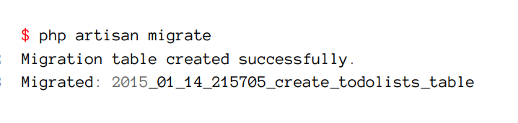

4. Which command is used to see migration status?
a. $ php artisan migrate status
b. $ php artisan migrate:status [pg-77]
c. $ php artisan migration:status
d. None

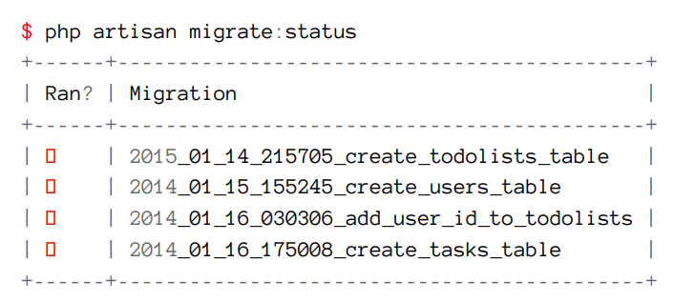

5. In laravel accessors means _____ [pg-77]
a. Member Functions
b. Events
c. Getter Functions
d. Setter functions
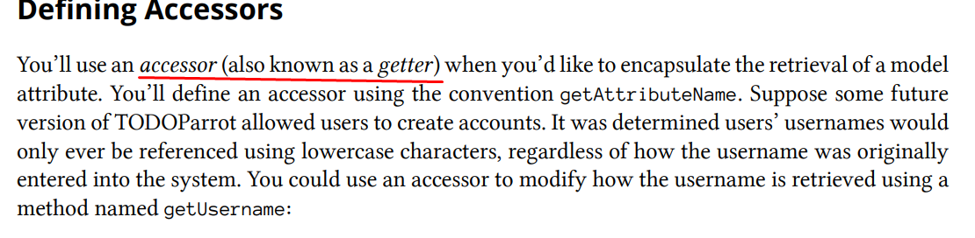

6. In laravel mutators means ______ [pg-78]
a. Setter functions
b. Getter functions
c. Events
d. Member functions

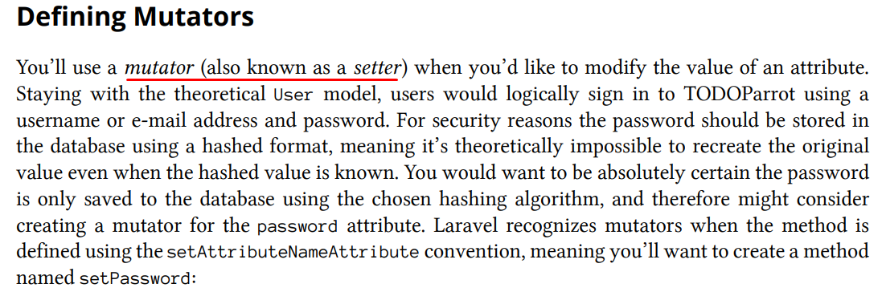

7. Which variable is used to validate your model in laraval? [Not sure. Please check out pg-80]
a. $this->validate
b. $validation
c. $this->rules
d. $validation_rules
[according to vcampusbd]
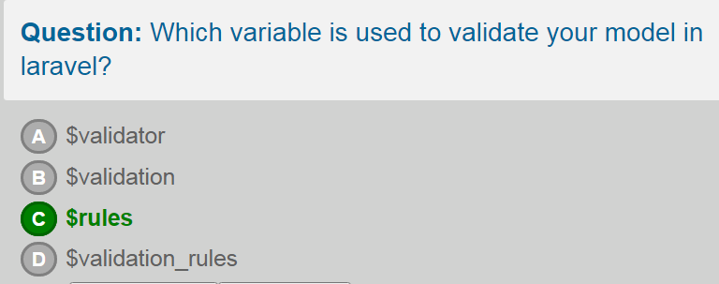
8. Which function is used to retrieve a single record from a table by primary key in laraval?
a. App\MyModel::find_by_id()
b. App\MyModel::find_id()
c. App\MyModel::find()
d. None
9. Which laravel function is used to make pagination?
a. {!! $data->render() !!} [pg-104]
b. {!! $data->paginate() !!}
c. {!! $data->pages() !!}
d. None
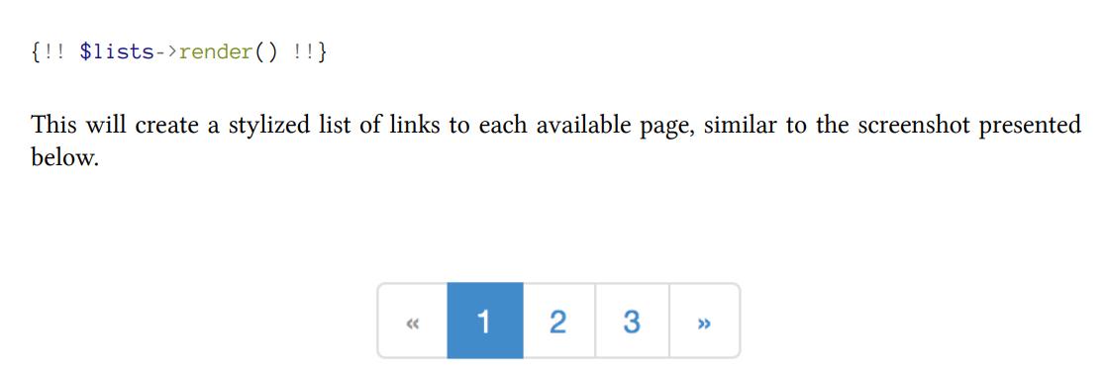
10.How can you insert a new record in the table in laravel? [vcampusbd]
a. $row=new MyModel;
$row->field1=’Field1 Value’
$row->save()
b. $row=new MyModel;
$row->field1=’Field1 Value’
$row->insert()
c. $row=new MyModel;
$row->field1=’Field1 Value’
$row->create()
d. $row=new MyModel;
$row->field1=’Field1 Value’
$row->add()
11.How can you update an existing record? [vcampusbd]
a. $row=new MyModel;
$row->field1=’Field1 Value’
$row->save()
b. $row=new MyModel;
$row->field1=’Field1 Value’
$row->insert()
c. $row=MyModel::find($id);
$row->field1=’Field1 Value’
$row->create()
d. $row=MyModel::find($id);
$row->field1=’Field1 Value’
$row->save()

12.How can you delete a record from a table in laraval? [vcampusbd]
a. $row=new MyModel::find($id);
$row->delete()
b. $row=new MyModel::find($id);
$row->clear()
c. MyModel::destroy($id);
d. $row=new MyModel::delete($id);
13. Todolist::find(3) means
a. Select first 3 rows
b. Select last 3 rows
c. Select 3rd rows [pg-95]
d. None
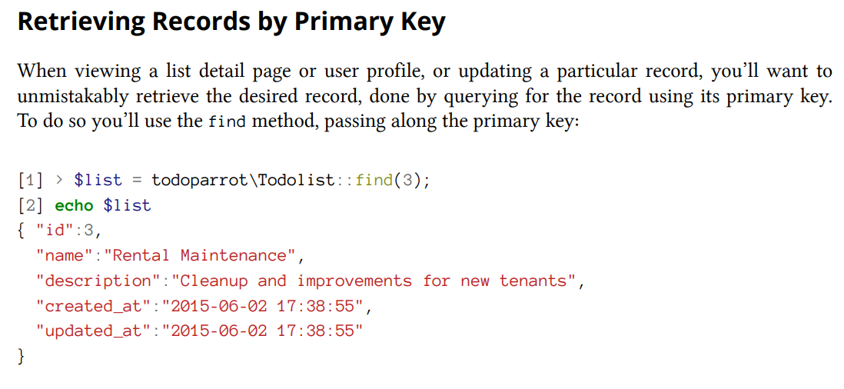

14. Which of the following is incorrect?
a. Todolist::orderBy(‘name’)->get();
b. Todolist::orderBy(‘name’, ‘desc’)->get();
c. Todolist::orderBy(‘desc’, ‘name’)->get();
d. Todolist::orderBy(‘name’, ‘desc’)->orderBy(‘id’, ‘desc’)->get();

15. Which of the following is incorrect? [pg-99]
a. Todolist:where(‘complete’, ‘=’, 1)->get() ;
b. Todolist:where(‘complete’, 1)->get() ;
c. Todolist:where(‘complete= ?’, 1)->get() ;
d. Todolist:where(‘complete’, ‘?’, 1)->get() ;
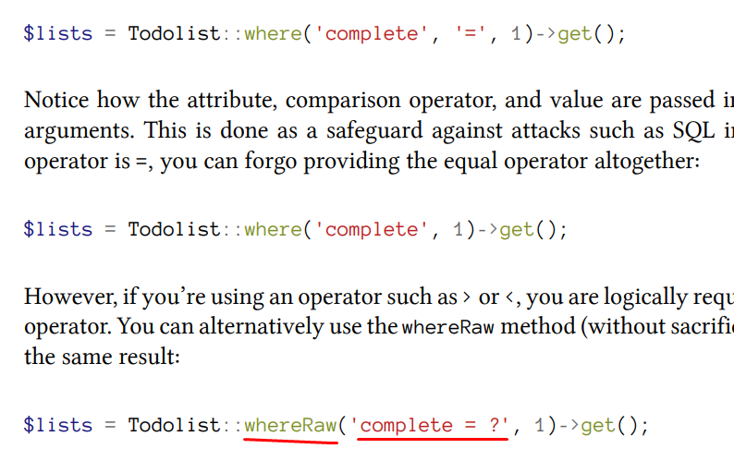

16. Todolist::take(5)->skip(10)->orderby(“id”, asc)->get() means
a. Select first 5 records after skipping 10 records
b. Select last 5 records after skipping 10 records
c. Select first 5 records
d. Select last 5 records

Chapter 4

1.CSRF stands for ______
(a) Cross System Rich Format
(b) Cross-Site Request Forgery
(c) Cross Scripting Reformative Function
(d) Cross Style Reporting Formula

2.What is the syntax to generate the form’s opening tags.
(a) Form::opening()
(b) Form::close()
(c) Form::open()
(d) Form::start()

3.Laravel supports only three types of relation.
(a) True
(b) False
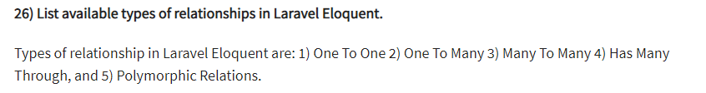

4.For creating form text fields Laravel uses ___
(a) Form::string
(b) Form::text area
(c) Form::text [pg-152]
(d) Form::submit

5. onDeleteCascade means deleting a user from the database will automatically delete corresponded data?
a. True
b. False

6. Keyword “Has Many” means
a. One to one relationship
b. One to many relationship
c. Many to many relationship
d. Belongs to relationship

7. The sync() method can accept an array? [pg-135]
a. True
b. False
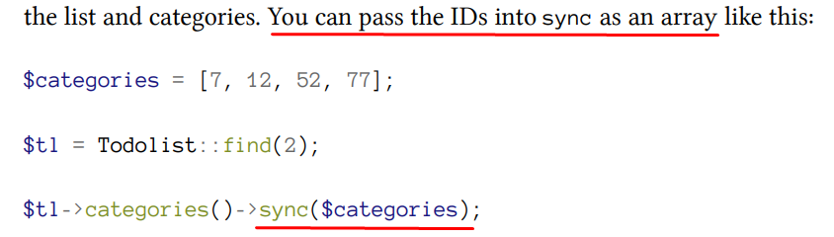
Chapter 5
1. How many parameters are accepted by Mail::send method? [pg-158]
a. Two
b. Three
c. Four
d. Five
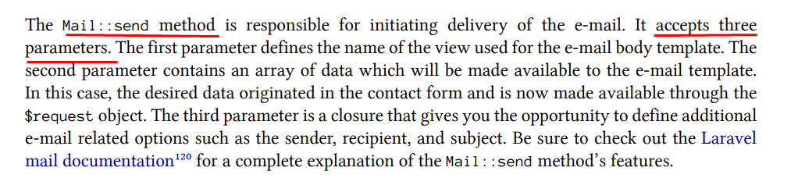

2. Which method is used when “editing” a record in RESTful service? [pg-83]
a. Get
b. Post
c. Put
d. Delete
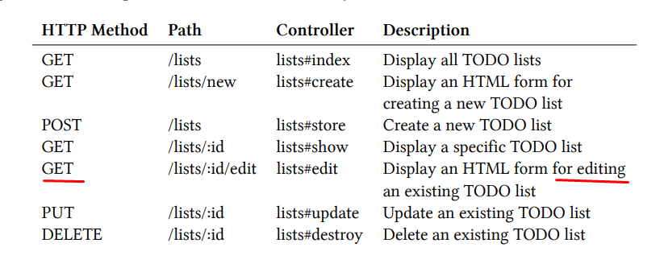

3. Which method is used when “destroying” a record in RESTful service?
a. Get
b. Post
c. Put
d. Delete

4. How many parameters are accepted by Form::select method? [pg-170]
a. Two
b. Three
c. Four
d. Five

5. For image upload, Form::file is a [pg-173]
a. Helper
b. Library
c. Third party
d. None
6. How to open a form in Laravel? [pg-152]
a. Form::open
b. Form::opens
c. Forms::open
d. Forms::opens
7. The cross-site request forgery stored randomly generated value and also in cookie [pg-147]
a. True
b. False
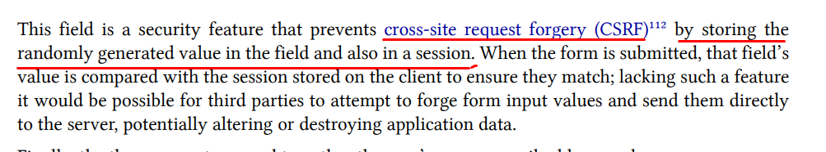

Chapter 6

1. Which middleware is used to confirm a user is signed in to the application. If not , the user is redirected to the login page. ?
A. Authenticated.php [pg-176]
B. RedirectIfAuthenticated.php
C. VerifyCsrfToken.php
D. AuthenticatedRedirect.php

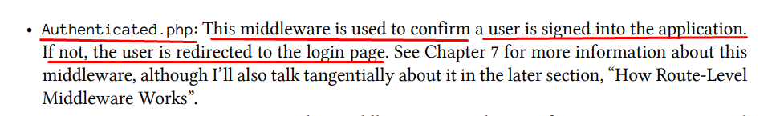

2.Whice middleware is used to manage CSRF protection?
A. TokenVerifyCsrf.php
B. RedirectIfAuthenticated.php
C. VerifyCsrfToken.php [pg-176]
D. RedirectCsrfToken.php

3.Which middleware is used to confirm a user is not signed in to the application . If so, the user is redirected to the home page?
A. Authenticate::class
B. AuthenticateWithBasicAuth::class
C. RedirectIfAuthenticated.php
D. Authenticated.php

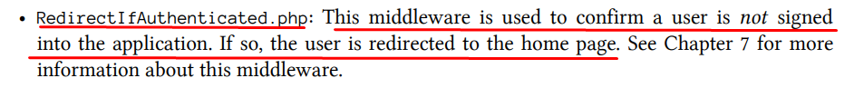

4.How many types of middleware in laravel?
A. 1
B. 2
C. 3
D. 4

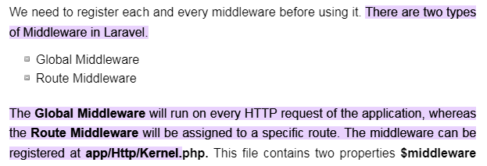

5.There are three types of middleware in laravel?
A. True
B. False

Chapter 7

6. How users will be retrieved and authenticated?
a. driver.
b. model.
c.table.
d. password.
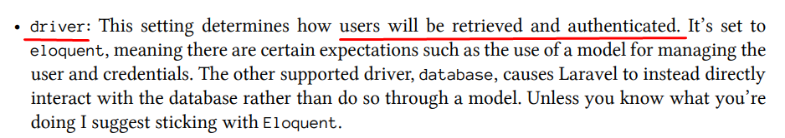

7. Authenticatable Contract defines an interface for obtaining the user’s unique identifier? [pg-186]
a. True.
b. False.
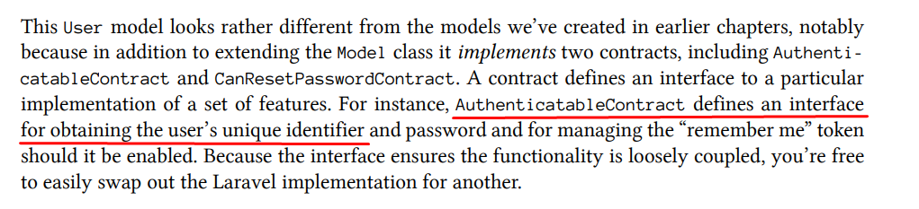

8. Which property identifies the columns that can be inserted/updated by way of mass assignment? [pg-186]
a.$colume
b.$hidden.
c.$fillable.
d.$table.

9. $ Which property is used to identify columns that should not be passed into JSON or arrays? [pg-186]
a.$colume
b.$hidden.
c. $fillable.
d.$table.
10. A contract defines an interface to a particular implementation of a set of features [pg-186]
a. True.
b. False.

Chapter 8
1. How can you cache using artisan command?
a. $ php artisan route : cache
b. $ php artisan route : clear
c. $ php artisan route : remove
d. $ php artisan route : destroy

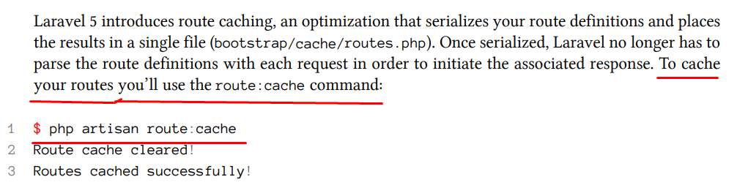

2. Within which file we can config our database connectivity?
a. Config/database.php [pg-65]
b. Routes/web.php
c. Database/Model factory.php
d. App/address.php

3. How can we update our gulpfile.js?
a. Mix.coffee(). scriptsIn(‘public/js’,’public/js’); [pg-206]
b. Mix.coffee(). scriptsIn(‘public/css’,’public/js’);
c. Mix.coffee(). scriptsIn(‘public/js’,’public/css’);
d. Mix.coffee(). scriptsIn(‘public/js’,’public/layout’);

4. Which artisan command use to encoding and serialization cache in routes [pg-205]
a. $ php artisan route : cache
b. $ php artisan route : class
c. $ php artisan route : complied
d. $ php artisan route : cached
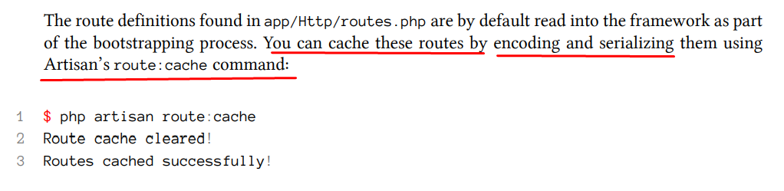

5. You shall migrate the database in laravel?
a. True
b. False

6. What is the purpose of laravel forge in laravel?
a. Conjunction with another hosting service [pg-213]
b. Connection with database.
c. Loading the full application.
D. none

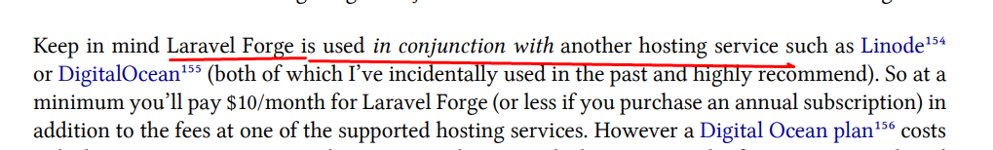

Chapter 9

1. ______ is a succinct and flexible way to add Role-based Permissions [pg-215]
a. Entrust
b. AuthPack.
c. elixir.
D. Gulp

2.Route::group(['prefix' => 'admin', 'namespace' => 'admin']
In this groupcontroller must be in _________ [pg-216]
- App\http\controller
- App\controller\admin
- App\http\controller\admin
- App\admin
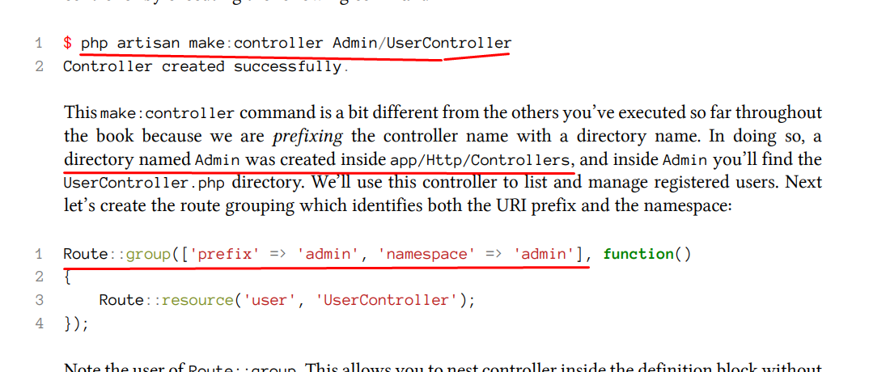
3._______ command created anew middleware skeleton named AdminAuthentication.php
- php artisan make:middlewareAdminAuthentication [pg-218]
- php artisansmake:middlewareAdminAuthentication
- php artisan make:middlewareAdminAuthentication.php
- php artisan create:middlewareAdminAuthentication
- How to load the database library?
$this->load->library();
$this->library->view();
$this->load->database();
$this->database->library();
- How to update the data using active record pattern?
$this->db->updated(‘mytable’, $object);
$this->db->ActiveRecord(‘mytable’, $object);
$this->db->update(‘mytable’, $object);
$this->db->updateData(‘mytable’, $object);
- How can we set controller?
Config
Routes
Autoload
Database

- Which of the following function used to change the error delimiter?
Set_error_delimiterset_error_delimeters
Set_errors_delimeter
Set_errors_delimeters
Set_error_delimeters

- Which function is used to set the value from the input box?
SetValue()
Set()
Set_value()
None of above
- Which function is used to find out current route name?
Request()->getName()
Request()->route->getName()
Request()->route->getName()
None
- What do you mean by laravel elixir?
An easy solution for compiling laravel project
A useful tool to create template in laravel
A debugging tool
- What is HTTP status Code?
203
503
604
300
- Which of the following artisan CLI command is used to update your project?
Php artisan update:my_app
Php artisan namespace:my_app
Php artisan update app
Php artisan app:namemy_project
- How can we get all routes?
Php artisan route:list
Php artisan listoutes
Php artisan routes
Php artisan getroutes
- Which of the following statement is correct?
It is MVC based framework
Is is open source
It is extensible
All of the above
- Where we set database credentials?
Session
Config
App
Resources
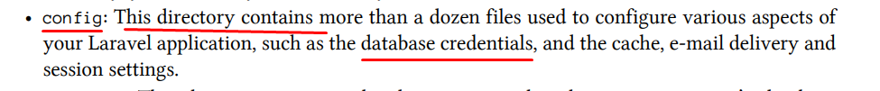
- Which directory contain a robot.txt file?
App
Config
Routes
Public
` Which of the following function is used to get the user IP Address in Codeigniter?
$this->ip_address();
$this->input_address();
$this->input->ip_address();
$this->ip->input_address();
- Which file is used to set database configuration?
Config.php
Autoload.php
Database.php
Model.php
- What is the role of middleware?
Ignore request
Process request and response
Send request
Get response
- Which of the following function of benchmark class is used to calculate usage of memory?
Memory();
Usage();
Memory_usage();
Memory_occupied();
- Which one will control all the segments?
Index.php
Parameters
Method
- Which function will remove the resource id associates with your query and free the associate memory?
$query->free_result();
$query->load->error();
$query->load->free_result();
$this->load->free_result();
- Which of the following is not cache function?
Start_cache();
Reset_cache();
Stop_cache();
Flush_cache();
- How can you change base URL?
Database
Config
Routes
Autoload
- Which function is used to delete all data from a table?
Delete_data();
Delete_table();
Empty_data()
Empty_table()
- Which of the following function escape only string data?
Escape()
Escape_str()
Escape_like_str()
All
- What is the purpose of composer.lock?
It is used to contain information about the state of the installed composer package at the time these packages were last installed and/or updates
It is used to lock all the packages so that it would never be change later.
It is used to contain information about the state of the installed composer package at the time when packages were first installed and updated.
- Which code id used to store session data?
$this->session->set_userdata();
$this->session->userdata();
$this->session->unset_userdata();

